Lab report of investigation 1

——10.7 张奕恒 27

Investigation 1: Measuring

* 1. The length of a pen

1. (145.11 $±$ 0.01) mm.
   1. The inner width and outer width of a measuring cylinder
2. Inner width (26.97 $±$ 0.01) mm.
3. Outer width (29.80 $±$ 0.01) mm.
   1. The diameter of a piece of wire
4. (1.296 $±$ 0.001) mm.
   1. The mass of water in a measuring cylinder
5. Mass of cylinder (81.0 $±$ 0.1) g.
6. Mass of cylinder and water in total (158.1 $±$ 0.1) g.
   1. The volume of water in measuring cylinder
7. Volume (69.5 $±$ 0.5) ml.
   1. The temperature of running water
8. (25.5 $±$ 0.5) ℃.
   1. The time for a piece of paper to fall from the desk
9. (0.59 $±$ 0.03) s.
   1. Determine the density of a metal cylinder
10. Raw data table

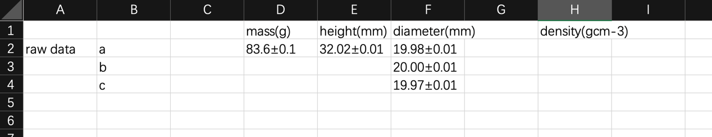

1. Calculation of mean value of the diameter:

(19.98+20.00+19.97)/3 $≈$ 19.98±0.03 mm.

1. Mean volume

Mean diameter^2\*π\*height/4 = 19.98^2\*π\*32.02 = 40157mm3 = 40.157cm3

1. Mean density

Mean mass/mean volume = 83.6/40.157 $≈$ 8.33gcm-3

1. Uncertainty

0.1/83.6+0.01/32.02+0.03/19.98\*2 $≈$ 0.0045 = 5%

8.33\*5% = 0.42gcm-3

1. Processed data table

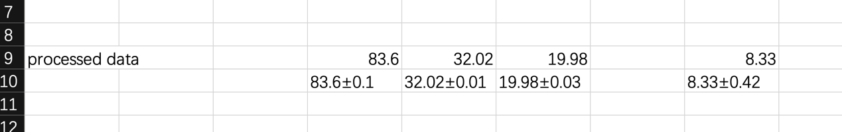

1. Result

The density with uncertainty we get from the data is 8.33±0.42gcm-3